1. Creating and Renaming Files/Directories
Create a directory named test_dir using mkdir.
Inside test_dir, create an empty file called example.txt.
Created test_dir folder and inside that folder I have created example.txt file
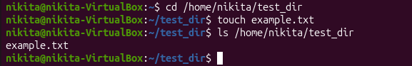

Created test_dir folder, then
Rename example.txt to renamed_example.txt using mv
Renamed example file to renamed_example

2. Viewing File Contents
Use cat to display the contents of /etc/passwd.
Used cat command here to show content of /etc/passwd path
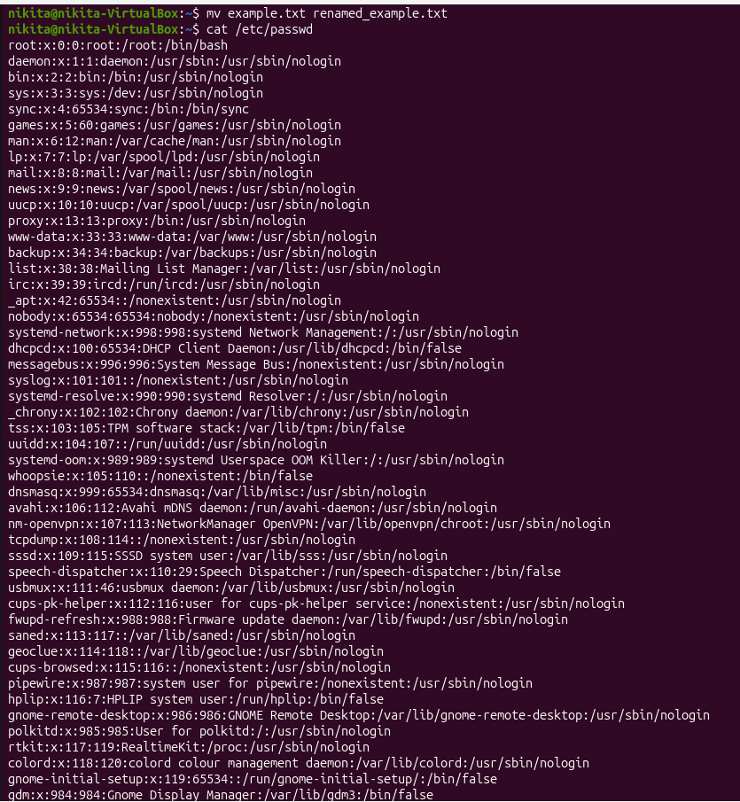Display only the first 5 lines of /etc/passwd using head.
Head command showing first line, so to show first 5 lines here I used head -n 5 cmd

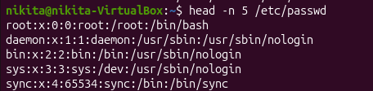
Display only the last 5 lines of /etc/passwd using tail.
Tail command showing last line, so to show last 5 lines here I used tail -n 5 cmd
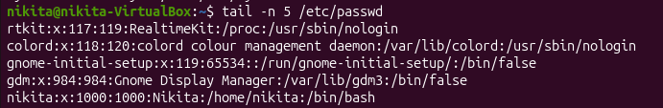

3.Searching for Patterns
Use grep to find all lines containing the word "root" in /etc/passwd.
Here in mentioned etc/passwd path how many times root contained show by using below command.

4. Zipping and Unzipping
Compress the test_dir directory into a file named test_dir.zip using zip.
Compressed test_dir directory and named as test_dir.zip

Unzip test_dir.zip into a new directory named unzipped_dir.
Unzipped test_dir.zip file, created unzipped_dir folder and moved zip file into it
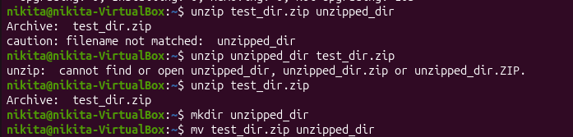

5. Downloading Files
Use wget to download a file from a URL (e.g., https://example.com/sample.txt).
We can download file from URL by using wget command, so here to downloaded file of mentioned URL by using wget command
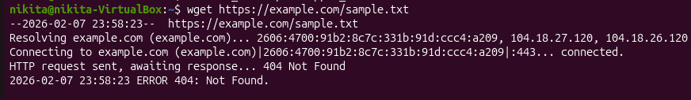

6. Changing Permissions
Create a file named secure.txt and change its permissions to read-only for everyone using chmod.
Created secure file and changed that file permissions to ready only for everyone by using below command

7. Working with Environment Variables
Use export to set a new environment variable called MY_VAR with the value "Hello, Linux!".
Output will show as “Hello,Linux!”as a content of MY_VAR

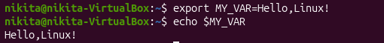
Submission Guidelines -: Attach Screenshots or command along with explanation and submit in doc(google doc or microsoft doc) format also attach github repo link

